**Assessment of Marginal Workers in Tamil Nadu- A Socioeconomic Analysis**

|  |  |
| --- | --- |
| **Date** | **10-10-2023** |
| **Team ID** | **4498** |
| **Project Name** | **Assessment of Marginal Workers in Tamil Nadu- A Socioeconomic Analysis** |

**Table of Contents**

|  |  |
| --- | --- |
| 1 | Introduction |
| 2 | Problem Statement |
| 3 | Design and Innovation Strategies |
| 3.1 | Data Collection and Feature Engineering |
| 3.2 | Data Pre-processing |
| 3.3 | Model Selection and Training |
| 3.4 | Geographic Analysis |
| 3.5 | Market Sentiment Analysis |
| 3.6 | Explainable AI (XAI) |
| 3.7 | Continuous Learning |
| 4 | Conclusion |

1. **Introduction**

This analysis delves into the socioeconomic dynamics of marginal workers in Tamil Nadu, India. We will examine key demographics, including age, industrial category, and gender distribution, using insightful visualizations to highlight the challenges faced by this vulnerable group. By viewing their profiles, this study aims to inform targeted policies and initiatives that can uplift the marginalized workforce in Tamil Nadu.

**2. Problem Statement**

The project involves analyzing the demographic characteristics of marginal workers in Tamil Nadu based on their age Industrial category, and sex. The objective is to perform a socioeconomic analysis and create visualizations to represent the distribution of marginal workers across different categories. This project includes defining objectives, designing the analysis approach, selecting appropriate visualization types, and performing the analysis using Python and data visualization libraries.

**3. Design and Innovation Strategies**

**3.1. Data Collection and Feature Engineering**

Innovation: Application of deep learning techniques for automated feature extraction.

Deep learning models, such as Convolutional Neural Networks (CNNs) and Recurrent Neural Networks (RNN), can be employed to automatically identify and extract relevant features from raw data. This approach is particularly beneficial when dealing with unstructured data like text, images, or time series. By allowing the model to learn and extract features on its own, it reduces the need for manual feature engineering and can uncover complex patterns that might be challenging to capture through traditional methods.

**3.2. Data Pre-processing**

Innovation: Automated data pre-processing tools and pipelines.

These tools leverage machine learning and artificial intelligence algorithms to automatically detect and address issues like missing data, outliers, and feature engineering. They can intelligently impute missing values, detect and handle outliers, and even suggest relevant feature transformations. Automated data pre-processing not only saves time but also reduces the risk of human error, making it a valuable innovation for data analytics projects.

**3.3. Model Selection and Training**

Innovation: AutoML (Automated Machine Learning) platforms.

AutoML leverages artificial intelligence to automate the process of selecting the best machine learning algorithms, hyperparameter tuning, and model training. It streamlines and accelerates the model development process, making it accessible to individuals with varying levels of expertise. AutoML platforms can automatically test multiple algorithms and configurations, selecting the most suitable one for a given dataset, thereby optimizing model performance.

**3.4. Geographic Analysis**

Innovation: Geographic Information Systems (GIS) with advanced data analytics techniques.

GIS allows for the visualization, analysis, and interpretation of geographic data, enabling a deeper understanding of the spatial relationships within the dataset. By overlaying socio-economic data with geographic information, analysts can identify spatial patterns, hotspots, and correlations that might not be evident through traditional analysis methods. Moreover, the incorporation of real-time and remote sensing data from satellites and IoT devices has expanded the scope of geographic analysis, allowing for near real-time monitoring of changes in socio-economic indicators and environmental conditions.

**3.5. Market Sentiment Analysis**

Innovation: Natural language processing (NLP).

The integration of alternative data sources, such as satellite imagery, social media sentiment, and geolocation data, has expanded the scope of market sentiment analysis. These innovations offer a more comprehensive understanding of market dynamics and help in making data-driven investment decisions. In the context of your project, these innovations in market sentiment analysis could provide valuable insights into how sentiment in Tamil Nadu may influence the socio-economic conditions of marginal workers and inform evidence-based decision-making.

Top of Form

**3.6. Explainable AI (XAI)**

Innovation: Model Interpretability.

This involves designing AI systems that can provide explanations using natural language or intuitive visual representations. For instance, when assessing marginal workers in Tamil Nadu, an XAI-powered model could not only make predictions but also explain the key factors influencing those predictions in a way that policymakers, stakeholders, and the marginalized workers themselves can easily comprehend.

**3.7. Continuous Learning**

Innovation: Online learning algorithms and techniques.

Online learning allows your models to adapt and update themselves as new data becomes available, without the need for periodic retraining from scratch. This approach is particularly useful in dynamic environments where data distributions may change over time. By continuously updating your models and analysis with the latest data, you can ensure that your insights and recommendations remain up-to-date and accurate.

Note: In the diagram below, we've depicted the key components and interactions described in sections 3.1 to 3.7, offering a clear and concise overview of our solution architecture. This visualization simplifies the complex concepts and relationships discussed in those sections, making it easier for the reader to grasp the overall design and innovation strategies at a glance.

STEP 1 : Data collection STEP 2 :Data processing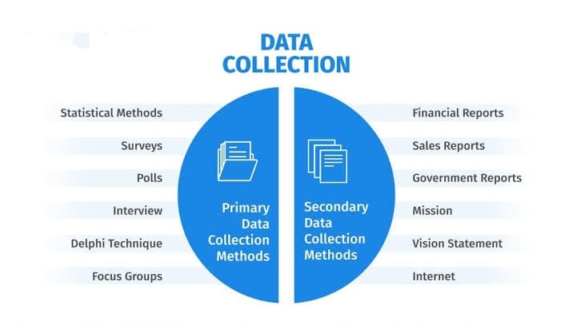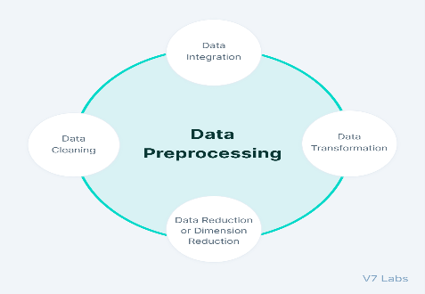

STEP 3 : Machine learning algorithm 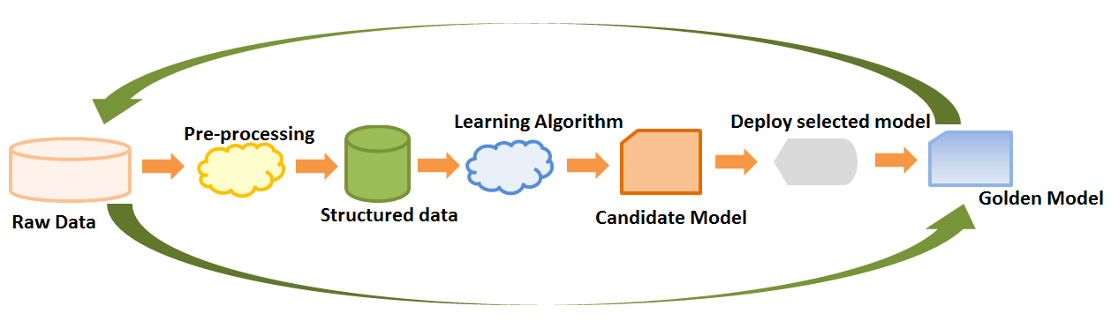

STEP 4 : Geographic analysis STEP 5 : Data vizualization

 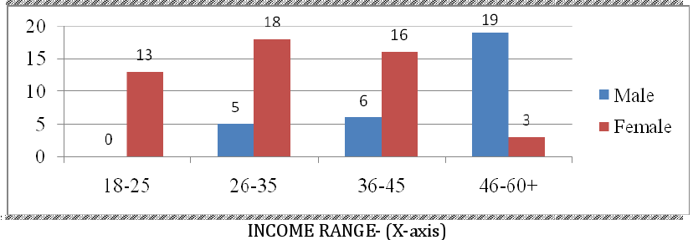

**4. Conclusion**

The assessment of marginal workers in Tamil Nadu is a crucial undertaking to address their socio-economic challenges. Through data analysis and a user-friendly web interface, this project aims to provide support evidence-based decision-making continuous improvement and model refinement are essential for the success and relevance of this initiative. Ultimately, this endeavour strives to improve the well-being and inclusion of marginal workers, fostering positive socio-economic changes in Tamil Nadu.